Augur Assistant - Future Planning & Docs

Sahana Sreeram - Software Engineering Intern

Working Repo:<https://github.com/redhat-et/augur-chatbot>

### Background & Motivation

Augur Assistant transforms how Red Hat and the CHAOSS community access project health data by layering a natural-language agent over our OSPO-managed Augur database of 40K+ repositories. The capabilities and goals of the tool are as follows:

* Accessible Insights: Enables non-technical users (community managers, contributors) to run complex queries without SQL
* Boosts visibility: Scans real-time metrics on Red Hat’s open-source footprint and contributor affiliations, activity trends, license breakdowns
* Proves small-model inference: Validated a lightweight MCP-powered pipeline (Llama Instruct 3B) for domain-specific agents, opening the door to low-latency, tool-exec AI workflows across the organization.

### Tech Stack

| **Layer** | **Component** | **Role & Description** |
| --- | --- | --- |
| Model Serving | Ollama | * Self-hosted Llama models (3B or 7B Instruct) served via Ollama |
| Agent Orchestration | LlamaStack Agent | * Interprets “use execute_sql()” instructions * Emits structured execute_sql(sql="…") calls |
| Schema Retrieval | FAISS DB (stored in data folder) | * Takes in prewritten schema via augur_schema.json * Uses embedding model and saves to data * Indexes them for fast top-k lookup of relevant schema snippets |
| Tooling protocol | MCP Server | * Registers custom-written mcp_execute server * Routes LLM-generated SQL to the database connector |
| Data Source | Postgres Augur DB | * Read-only use of Augur DB * Connects via .env variables and database credentials |
| Frontend | Streamlit UI | * Optional SQL toggle and debug trace * Regex-driven parsing to render JSON results as clean text |

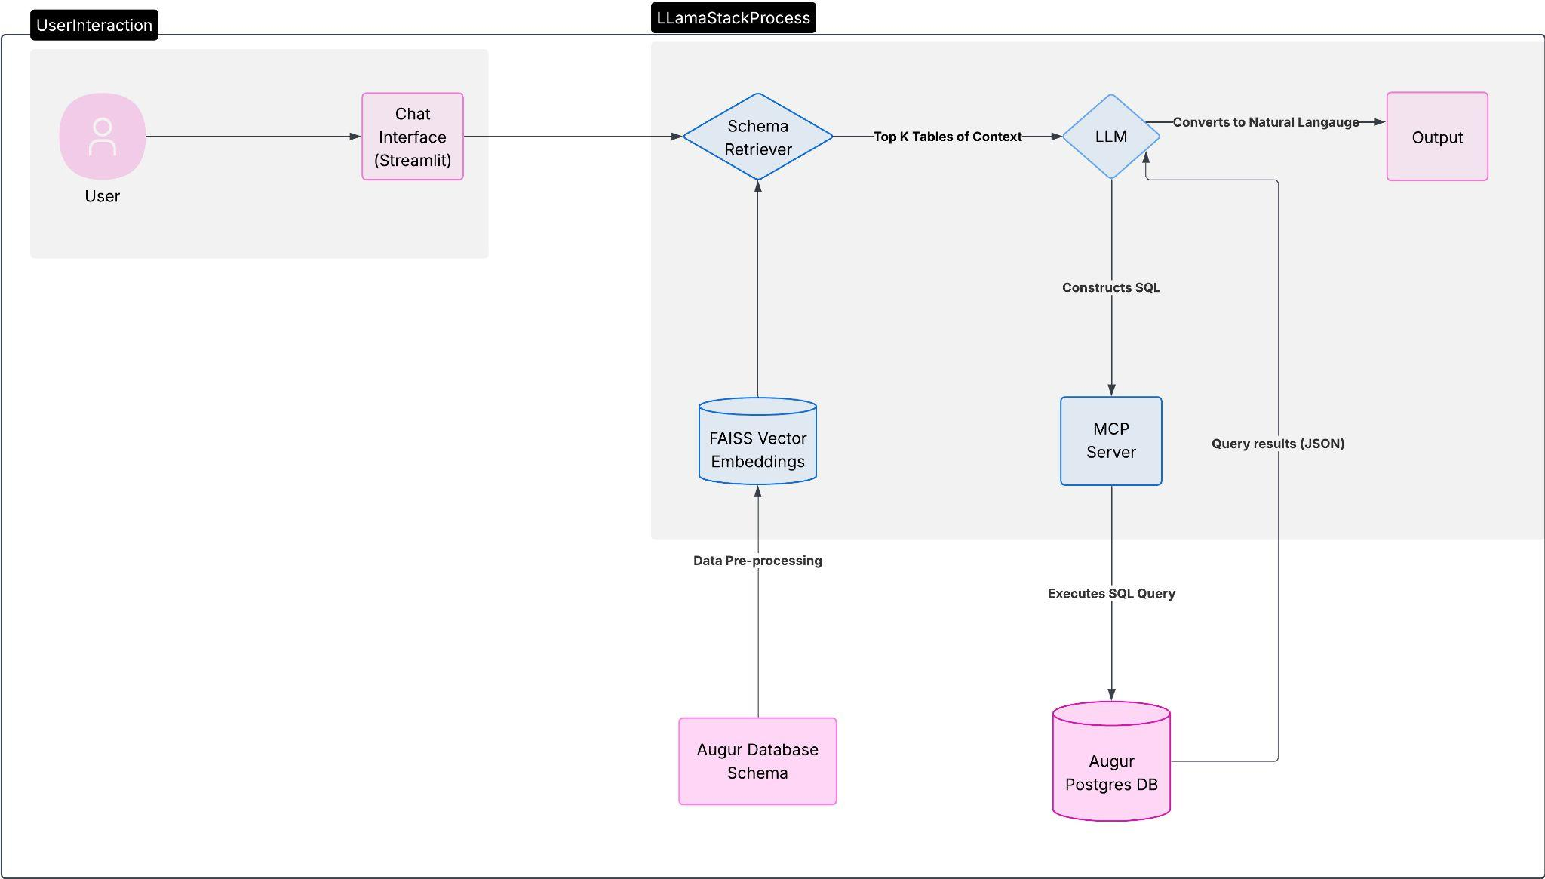

### Future planning:

| Challenge | Next Actions |
| --- | --- |
| Polish Final Output  Human-readable results only, get rid of SQL dump | Enhance ui.py with regex/JSON hooks to surface only human-readable text (with an optional toggle for raw output). |
| Simplify setup | Create a docker-compose that simplifies all the setup commands |
| Fix Intent Parsing step by reducing model hallucination | Challenge: Small-model errors and edge-case phrasing.  Next:   * Embed few-shot Q→SQL examples in the prompt. * Test larger models or non-Llama models. 7B versions seem to work much better than 3B * Better prompt tuning |
| Modular Agent-to-Agent Pipeline | Challenge: A monolithic agent struggles to juggle schema retrieval, SQL generation, execution and output formatting all at once.  Next:  Split responsibilities into specialized agents:   * Schema Agent – selects top K tables/columns * SQL Agent – builds valid queries * Execution Agent – runs the SQL via MCP * Output Agent – parses and converts to NL   Orchestrate them in a lightweight workflow (feedback per Josh Berkus). |
| Build an Augur Playground for Red Hatters to access without setup | Challenge: Requires individual Augur instances/credentials.  Next:   * Offer a managed “playground” Augur DB pre-loaded with RH data. * Provide a one-click Docker/SQLite snapshot for local demos. * Implement role-based access for unredacted metrics. |
| Broaden integration | A last step could be to turn Augur Assistant into a Red Hat-specific Discord bot, or integrate with Ask Red Hat |

### Project ownership

* Handoff to OSPO (post-Summer 2025)
  + Formal transfer of code, documentation, and support for future planning responsibilities
* Upstream community
  + Opportunity to partner with the upstream CHAOSS community in the Data Science Working Group
  + Some members of the community have expressed interest in AI/ML/agentic workflows. This project could be an area for them to work on. ** Especially integration with A2A
* Long-term support:
  + OSPO to maintain the production-hosted Augur Assistant instance.
  + CHAOSS to own the open-source roadmap, issue triage, and model updates.